

**IOT BASED SAFETY GADGET FOR CHILD SAFETY**

**MONITORING AND NOTIFICATION**

# Domain : IOT

# A PROJECT REPORT

***Submitted by***

|  |  |
| --- | --- |
| **A.AFRIN SHIFANA** | **(920819106002)** |
| **P.SNEHA** | **(920819106060)** |
| **M.KEERTHI** | **(920819106024)** |
| **S.DHATHVEHTA** | **(920819104008)** |

***in partial fulfillment for the award of the degree***

***of***

**BACHELOR OF ENGINEERING**

# *in*

COMPUTER SCIENCE AND ENGINEERING

# NPR COLLEGE OF ENGINEERING & TECHNOLOGY

# NATHAM, DINDIGUL.

**ANNA UNIVERSITY:: CHENNAI 600 025**

# TABLE OF CONTENTS

**CHAPTER NO. TITLE PAGE NO.**

# INTRODUCTION

* 1. Overview 1
  2. Purpose 2

1. **LITERATURE SURVEY**
   1. Existing problem 3
   2. References 8
   3. Problem Statement Definition 10
2. IDEATION & PROPOSED SOLUTION
   1. Empathy Map Canvas 11
   2. Ideation & Brainstorming 13
   3. Proposed Solution 16
   4. Problem Solution Fit 17
3. REQUIREMENT ANALYSIS
   1. Functional requirement 18
   2. Non-Functional requirements 19
4. PROJECT DESIGN
   1. Data Flow Diagram 20
   2. Solution & Technical Architecture 21
   3. User Stories 23
5. PROJECT PLANNING & SCHEDULING
   1. Sprint Planning & Estimation 24
   2. Sprint Delivery Schedule 25
   3. Reports from JIRA
6. CODING & SOLUTIONING
   1. Feature 1 27
   2. Feature 2 29
7. **TESTING**
   1. Test Cases 30
   2. User Acceptance Testing 31
8. **RESULTS**

9.1 Performance Metrics 33

# ADVANTAGES AND DISADVANTAGES 34

# CONCLUSION 35

# FUTURE SCOPE 36

# APPENDIX 30

SOURCE CODE 30

GITHUB & PROJECT DEMO LINK 32

**Project Report**

|  |  |
| --- | --- |
| Date | 26 November 2022 |
| Team ID | PNT2022TMID48656 |
| Project Name | Project – IOT-Based Safety Gadget for Child Safety Monitoring and Notification |

1. **INTRODUCTION**

a. Project Overview

b. Purpose

2. **LITERATURE SURVEY**

a. Existing problem

b. References

c. Problem Statement Definition

3. **IDEATION & PROPOSED SOLUTION**

a. Empathy Map Canvas

b. Ideation & Brainstorming

c. Proposed Solution

d. Problem Solution fit

4. **REQUIREMENT ANALYSIS**

a. Functional requirement

b. Non-Functional requirements

5. **PROJECT DESIGN**

a. Data Flow Diagrams

b. Solution & Technical Architecture

c. User Stories

6. **PROJECT PLANNING & SCHEDULING**

a. Sprint Planning & Estimation

b. Sprint Delivery Schedule

7. **CODING & SOLUTIONING**

a. Coding

b. Geo-Fence

8. **RESULTS**

a. Performance Metrics

9. **ADVANTAGES & DISADVANTAGES**

10.**CONCLUSION**

11.**FUTURE SCOPE**

12.**APPENDIX**

Source Code

GitHub & Project Demo Link

**Chapter 1**

**1.INTRODUCTION**

**1.1 Project Overview**

Child tracker helps the parents in continuously monitoring the child's location. They can simply leave their children in school or parks and create a geofence around the particular location. By continuously checking the child's location notifications will be generated if the child crosses the geofence. Notifications will be sent according to the child's location to their parents or caretakers. The entire location data will be stored in the database. Basically, children cannot complain about abusements which they face in their daily life to their parents. They can’t even realize what actually happens to them at their age. It is also difficult for parents to identify their children are being abused. Since to prevent children before being attacked, an autonomous real-time monitoring system is necessary for every child out there. In this system, the collected values from every sensor like temperature sensor, pulse rate detection sensor, metal detection sensor, and the location value from GPS are used to detect the status of the child and alerts the respective guardians using GSM accordingly.

**1.2 Purpose**

It assists parents to monitor their children remotely. In case situations happen, notifications will be sent to parents so that actions can be taken. Through this, child safety can be ensured. By this, parents know what is happening remotely and can take actions if something goes wrong. It provides parents with the real

time location to monitor the child. It makes parents to make monitor their child from their workplace.Parents can be relax and calm by using this device.

**Chapter 2**

**2.LITERATURE SURVEY**

**2.1 Existing Problem**

Parents need to ensure safety of their children but in realtime they need to get to work and need to worry about their child whether he/she is safe or not.So to ensure safety they need to monitor & to notify their child what he/she is doing and to know whether they are in safe atmosphere or not to ensure the safety of the child.

Real-Time Child Abuse and Reporting System In the existing system, we use a voice recognition module in which the alert commands from the child are stored and kept for further reference. If the same child delivers the same command, it will compare with the alert command which was previously stored and sets an emergency level according to the alert command. The GSM has a SIM which is used to send an alert message or an alert call to the trusted peoples. GPS is used to track the live location and it is used when needed. The server will search the respective device ID from the database and search for respective contacts according to that device ID and helps in alerting the registered guardians. The disadvantage of this project are,

i. The child could not produce the exact alert command during a panic condition. ii. The command produced may not match with the previously stored command. iii. This project requires manual intervention.

**2.2 References**

• A. Jatti, M. Kannan, R. M. Alisha, P. Vijayalakshmi and S. Sinha, "Design and development of an IOT based wearable device for the safety and security of women and girl children," 2016 IEEE International Conference on Recent Trends in Electronics, Information & Communication Technology (RTEICT), Bangalore, 2016, pp. 1108-1112.

• David Hanes, Gonzalo, Patrick Grosetete, Robert, Barton, Jerome Henry “IoT Fundamental and Networking Technologies, Protocols”.

* AkashMoodbidri, Hamid Shahnasser, ”Child Safety Wearable Device”, Department of Electrical and Computer Engineering San Francisco State University.
* [2] AnandJatti, MadhviKannan , Alisha RM, Vijayalakshmi P, ShresthaSinha, " Design and Development of an IOT based wearable device forthe Safety and Security of women and girl children “, IEEE International Conference On Recent Trends In Electronics Information Communication Technology, May 20-21, 2016, India.
* [3] Anwaar Al-Lawati, Shaikha Al-Jahdhami,
* [4] " RFID-based System for School Children Transportation Safety Enhancement ", Proceedings of the 8th IEEE GCC Conference and Exhibition, Muscat, Oman, 1-4 February 2015.
* [5] Dr. R. Kamalraj, ” A Hybrid Model on Child Security and Activities Monitoring System using IoT”, IEEE Xplore Compliant Part Number: CFP18N67-ART; ISBN:978-1-5386-2456-2
* . [6] Pooja.K.Biradar1, Prof S.B.Jamge2,” An Innovative Monitoring Application for Child Safety”, DOI:10.15680/IJIRSET.2015.0409093.
* [7] Prof. Sunil K Punjabi, Prof. Suvarna Chaure, "Smart Intelligent System for Women and Child Security” Department of Computer Engineering SIES Graduate School of Technology Nerul, Navi Mumbai, India.
* [8] Sarifah Putri Raflesia, Firdaus, Dinda Lestarini, “An Integrated Child Safety using Geo-fencing Information on Mobile Devices", INTERNATIONAL CONFERENCE ON ELECTRICAL ENGINEERING AND COMPUTER SCIENCE (ICECOS) 2018.
* [9] Zejun Huang1, ZhigangGao,” An Mobile Safety Monitoring System for Children”, 2014 10th International Conference on Mobile Ad-hoc and Sensor Networks.-
* **2.3 Problem Statement Definition**

The objective of this project is to safeguard the child from threads. Now a days the safety measures of children has been reduced in huge number. Thus the violence against children increasing day by day.Our project mainly focus on sensing the children’s Temperature and Heartbeat. By monitoring the activities the state of the child is analyzed. By using GSM, if child reaches the critical state then the latitude and longitude of that particular location is sent as an alert message to the parents.

|  |  |  |  |  |
| --- | --- | --- | --- | --- |
| **SI.No** | **AUTHOR** | **YEAR** | **JOURNAL NAME** | **ABOUT** |
| 1 | N. Senthamilarasi N. Divya Bharathi | 2012 | Child Safety Monitoring System Based on IoT | It makes parents to easily monitor their children in real time just like staying beside them as well as  focusing on their own  career without any manual intervention. |
| 2 | M Nandini  Priyanka,  S Murugan,  K N H Srinivas, T D S  Sarveswararao, E Kusuma  Kumari. | 2019 | International Journal of Innovative Technology and Exploring Engineering (IJITEE)  Smart IOT Device for Child Safety and Tracking  https://www.ijitee.org/wp content/uploads/papers/v8i 8/H6836068819.pdf | The novelty of the work is that the system  automatically alerts the parent/caretaker by sending SMS, when immediate attention is required for the child during emergency |
| 3 | Mr.Vinod Mane, Durgesh Musale, Rohan Joshi,  Aditya Toney,  Anand Pande,  Shashank Kohade | 2020 | IoT Enabled Children Safety System  (International Research Journal of Engineering and Technology (IRJET))  https://www.irjet.net/archi ves/V7/i1/IRJET  V7I143.pdf | It is a IOT based project and their approach is to monitor school bus in this new era of smart cities |
| 4 | Lai Yi Heng,  Intan Farahana  Binti Kamsin | 2021 | (Proceedings of the 3rd International Conference on Integrated Intelligent Computing  Communication &  Security (ICIIC 2021)  IoT-based Child Security Monitoring System | Enable tracking of the  child’s location and  capturing of data remotely such as temperature, pulse, respiratory rate, quality of sleep and many more. To  show the child's actual data with reference values.• |
| 5 | Fathima, N.,  Ahammed, A.,  Banu, R., | 2017 | Optimized neighbor  discovery in Internet of Things (IoT). | This device helps in  optimized discovery of the child using data collected |

|  |  |  |  |  |
| --- | --- | --- | --- | --- |
|  | Parameshachari, B.D  Naik, N.M |  | ( International Conference on Electrical, Electronics, Communication,  Computer, and  Optimization Techniques (ICEECCOT) (pp. 1-5). IEEE.) |  |
| 6 | Prakriti Agarwal, R Ramya,  Rachana  Ravikumar,  Sabarish G,  Sreenivasa Setty | 2020 | Survey on Child Safety Wearable Device Using IoT Sensors and Cloud Computing  (International Journal of Innovative Science and Research Technology) | The design of this model involves developing a  medium for communication between the parent/guardian and the child’s wearable device. The child’s location is tracked using GSM  mobile communication to specify the location of the child in real-time. |
| 7 | Mrs. P Chitra,  Aarthi S,  Anitha K,  Angammal R,  Abinaya D | 2022 | Monitoring and  Prevention of Child  Abuse Using IoT  https://www.ijraset.com/re search-paper/monitoring and-prevention-of-child abuse-using-iot | This paper focuses on the important issue of how people surrounding a  missing child can assist the youngster and play a crucial role in the child's safety and health monitoring until they are reunited with their  parents. |
| 8 | Dr. T. VP.  Sundararajan | 2018 | Activity Tracker  Wrist Band for  Children Monitoring  using IOT | The children with Activity Tracker that has access to IOT monitoring and GSM technology keeps  monitoring the children. The system has sensors interfaced with the  processor which keeps sensing the vital signals such as heart beat rate, temperature, etc. So  whenever some perilous situations arise there may be an indication to parents |
| 9 | Pietro Battistoni *ORCID,Monica SebilloORCID | 2021 | An IoT-Based Mobile System for Safety  Monitoring of Lone  Workers | This paper proposes a  distributed solution of  Smart Personal Protective Equipment for the safety |

|  |  |  |  |  |
| --- | --- | --- | --- | --- |
|  | andGiuliana  Vitiello |  |  | monitoring of Lone  Workers by adopting low cost electronic devices. In addition to the same  hazards as anyone else, Lone Workers need  additional and specific systems due to the higher risk they run on a work site. To this end, the *Edge*  *Computing* paradigm can be adopted to deploy an  architecture embedding wearable devices, which alerts safety managers when workers do not wear the prescribed Personal  Protective Equipment and supports a fast rescue when a worker seeks help or an accidental fall is  automatically detected. |
| 10 | Fei Mingming , Shi Y anli | 2014 | Design and implementation anti-lost children system based on internet of things | In this paper, the current rapid development of  society for children brought to this reality is lost,  combined with existing and emerging technologies, Internet of Things in life related application solutions proposed, which can be determined at any location to avoid the safety of  children parents worry about other issues.  Although at present no specific implementation, and the idea is still  preliminary stage, but levels of the method, rationality, practicality and  applicability have good theoretical basis, and the method utilizes advanced technology, with good scalability and adaptability, with some room for  development, there is a certain profit margin. |

**Chapter 3**

**3.IDEATION & PROPOSED SOLUTION**

**3.1 Empathy Map Canvas**

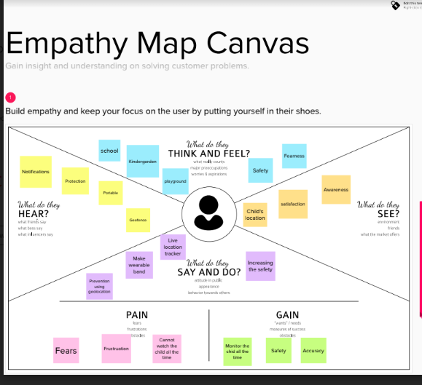

**3.2 Ideation & Brainstorming**

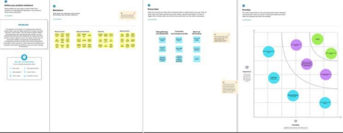

**Step-1: Team Gathering, Collaboration and Select the Problem Statement**

IoT or the internet of things is characterized as a forthcoming innovation that empowers us to create worldwide networked machines and also the devices that can be helped for exchanging of communication.

As we all know that the real-time application has been increasing day by day, the smart connection also had increased. Rapid population growth, led to the increase in global life expectancy and the advance of technology, paving the pathway for the creation of age-friendly environments. This had led to the necessity in designing new products for infants protection.

Infants or toddlers need parents’ attention 24×7. In this present era, the cases regarding missing children have been increasing day by day, which was the main motivation that comes for the safety of little children. However, the parents cannot continuously monitor their babies’ conditions either in normal or abnormal situations. Still, certain incidents like infant attacks have been reported, it is necessary to protect the baby.

**Step-2: Brainstorm, Idea Listing and Grouping**

**Team Member 1: A.Afrin Shifana**

Child and women safety is a challenging problem nowadays due to antisocial elements in the society. The crime rate is day by day increasing. Schools and working places need high surveillance for ensuring the safety among children and women. Smart phones are playing major role for ensuring the safety, where some mobile based applications provide alert systems. During the emergency, mobile apps alert the control room of nearby police station or caretakers of children. The literature shows that location tracking devices are available in the market, but it does not provide the complete solution to the problem. The solution to this

problem is to design an IoT device, which senses the child’s location and environment and during emergency, it should send the alert to the parents automatically.

**Team Member 2: P.Sneha**

The children are too young to take care of themselves. We cannot monitor the children at all times in school, play area, and outside place. In this paper, we discuss the concept of child safety device based on Internet of things. The aim of this device is to provide safety to the child by allowing the parent to locate the child and view their surroundings. This device can be used to monitor the temperature and motion of the child. If any problem persists, the GSM mobile communication module automatically sends a text message to the parent as SMS.

**Team Member 3: S.Dhathvetha**

Crimes on children keep increasing despite actions have been taken by the government. Revealed by [9], the overall percentage of child abasements worldwide is about 80% nowadays, out of which 74% are girls and the remaining are boys. For every 40 seconds, a child is gone missing in the world. Due to that, parents are worried for their children and perhaps, a hard challenge for them to guarantee safety of their children when they are out.

To cope with the issue, the system is proposed with these objectives:

Enable tracking of the child’s location and capturing of data remotely such as temperature, pulse, respiratory rate, quality of sleep and many more.

To show the child's actual data with reference values.

Enable sending of notification if the child is out of location or when the device realizes abnormal conditions/situations

**Team Member 4: M.Keerthi**

Develop a prototype of IoT wearable smart band connected to parents’ mobile apps so that they can monitor the actual condition of children at anytime and anyplace. Besides, unlike existing smart band, which is less focusing on child security aspect, the proposed system emphasizes in getting as much data as possible so that actual situation can be identified. , the information indicating children's status, along with reference values will be sent to parents’ devices with the app installed. If children’s actual data is not within the range of reference value, alert notification and some suggestions will be sent to parents’ devices. Also, when children leave geofences, notification will be sent to parents’ device.

**Step-3: Idea Prioritization**

The section mainly discussed about significant of the research and why this study needs to be carried out. The child security system benefits parents as well as children. Since it aids in locating children, monitoring child’s condition and security status instantly at anyplace and any time, parents who often tied up in work or neglect their children are gaining advantages from it. Through the proposed system, immediate

actions can be taken forthwith in case the child is threatened. Thus, child security is guaranteed, crime rate related to children is reduced and eventually, parents can rest assured. In fact, reduction of crime rate brings about long-term positive effects such as improving country's reputation and quality of life, increasing community security, safety, and cohesion as well as generating economic benefits for individuals, committee and taxpayers. Besides, the proposed system makes ample use of IoT, proving IoT is evolving which can be included in multiple areas comprising the child security field.

Throughout the research, it is clearly explained the IoT concept, child safety issues and the need of using child security system. Some previous studies have been included for designing the IoT-based child security smart band. It assists parents to monitor their children remotely. In case situations happen, notifications will be sent to parents so that actions can be taken. Through this, child safety can be ensured and crime rate will be reduced. However, the proposed device is not robust enough and does not contain sufficient functions to operate like a mobile phone. Hence, the future enchantments will be adding more features, software, applications, hardware to make the proposed system capable of working more intelligently,

meanwhile guarantee the safety of children

**3.3 Proposed Solution**

We also have a web camera through which we can monitor the child lively through live video streaming whenever we get notified in abnormal cases. We have an IP address for the camera fitted with the kit and we are supposed to enter that IP address in our mobile application or web application through which we can see the live video streaming of what's happening around the child as shown in the picture. we can monitor the child 24/7 in real time through the help of this live streaming which makes parents feel that they are beside their children ensuring children's safety.

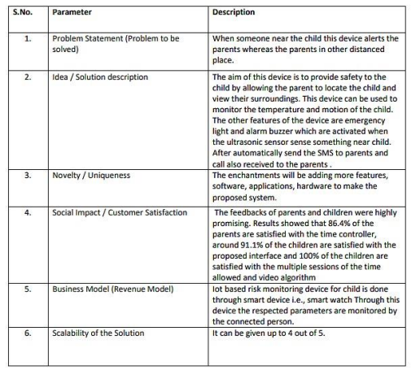

**3.4 Problem Solution fit**

|  |  |  |
| --- | --- | --- |
| 1. | CUSTOMER SEGMENT(S) | Our Customers are mainly parents who are working and do not have enough time to take care of their children. Such parents are not provided with availability at anytime to look after their children. If the case so they are in need of something to make their children under the surveillance of them. |
| 2. | JOBS-TO-BE-DONE/PROBLEMS | To enhance the operating condition of the developed solution the way it is not supposed to deal with any fault at any point of time so that the child safety can be highly ensured. To ensure the parents that their surveillance on their children can never be taken off |
| 3. | TRIGGERS | The trigger which induces the customers is the one that when other working parents give a try to this and comment a positive review on this, they also erdtoday center their |

|  |  |  |
| --- | --- | --- |
|  |  | childsafety. The trigger which induces the customers is the one that when other working parents give a try to this and comment a positive review on this, they also erdtoday center their childsafety. |
| 4. | EMOTIONS: BEFORE/AFTER | Customers(Parents) are being frustratesd that their children are doing safe or not before using the gadget designed. Once they start to use the developed solution they might feel free to focus on their work and also the surveillance of their children would happen with ease at any point of time |
| 5. | AVAILABLE SOLUTIONS | Of course the solutions are available readily in the market such as angel monitoring system, Child GPS Tracking System, Child Safety GSM Kit, etc.... One such constraint the customers facing are cost and inefficiencies in the working once purchased. |
| 6. | CUSTOMER CONSTRAINTS | The constraints our customers facing are such connectivity issues or may be the protocols being used for  communication. There may be chances of issues arised due to technical disefficiencies. Giving a second thought, price to be afforded for buying the developed solution kit might be the one they could not afford. |
| 7. | BEHAVIOUR | Our proposed solution has the modes of working in both offline and Online. In case of any disconnectivities happen the gadget which ha been developed might tend to work on a plan B ehich includes the backup of the failure of actual working kit. |
| 8. | CHANNELS of BEHAVIOUR | Our proposed solution has the modes of working in both offline and Online. In case of any disconnectivities happen the gadget which has been developed might tend to work on a plan B ehich includes the backup of the failure of actual working kit. |
| 9. | PROBLEM ROOT CAUSE | Considering the origination of the problem, it occurs in the base of merely irrespective persons that are no way relatable to the children but for the currency kind of thing and also the child abuse(mainly in case of girl children) |
| 10 | YOUR SOLUTION | Our Team has highly been intending to develop an efficient solution to overcome all the flaws that the existing solutions hold back still. We are highly on demand to ensure the efficient functionalities of the developing module the way it will not fail at anytime. |

**Chapter 4**

**4.REQUIREMENT ANALYSIS**

**4.1 Functional Requirements**

|  |  |  |
| --- | --- | --- |
| **SI No.** | **Functional Requirement**  **(Epic)** | **Sub Requirement (Story / Sub-Task)** |
| 1. | User Registration | Registration through Form  Registration through Gmail  Registration through LinkedIn |
| 2. | User Confirmation | Confirmation via Email  Confirmation via OTP |
| 3. | Authentication | Only the authorized person for that product will know Ensures security |
| 4. | User Interface | The Inventor Able to see the location of children when they are out of geofence will also track the exact information about the children |
| 5. | Notification | Notified through mobile and mail |

**4.2 Non- Functional Requirements**

|  |  |  |  |  |
| --- | --- | --- | --- | --- |
| **SI No.** | **Non-Functional Requirement** | | | **Description** |
| 1. | Usability | | | Accessed through Mobile App Showing location (latitude and longitude) of child and also other measures to ensure safety like notification. Portable and comfortable to use. |
| 2. | Security | | | Database security and ensuring the safety of the product while in use. |
| 3. | Reliability | | | Once logged in, the webpage is available until logging out of the app, and a comfortable platform or creates a good environment for users to use. |
| 4. | Performance | | | Each page must load within 4 seconds and database needs to be updated every few seconds and a notification must be sent immediately if seen a change in the child’s location. |
| 5. | Availability | | | The data must be available whenever needed and the product should be able to use at any time. |
| 6. | | | Scalability | The process must be flexible  to use at anytime .  . | |

**Chapter 5**

**5.PROJECT DESIGN**

**5.1 Data Flow Diagrams**

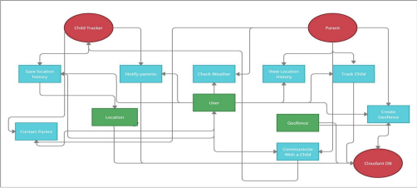

**5.2 Solution & Technical Architecture**

The device has IOT monitoring allows to monitor the child from anywhere with any portable devices. Ultrasonic sensor are used which sense when someone near child and alarm buzz will established SMS and dialing function is made to parent

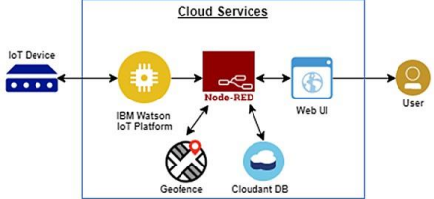**5.3 User Stories**

|  |  |  |  |  |  |  |
| --- | --- | --- | --- | --- | --- | --- |
| **User Type** | **Functional**  **Requirement (Epic)** | **User Story**  **Number** | **User Story / Task** | **Acceptance**  **criteria** | **Priority** | **Release** |

|  |  |  |  |  |  |  |
| --- | --- | --- | --- | --- | --- | --- |
| Customer  (Web user) | Registration | USN-1  (FATHER) | As a user, I can register by entering my email,  password, and confirming my password. I can access the location of my children using the credentials  provided as a Father. | I can access my account /  dashboard and receive  confirmation  email & click  confirm | High | Sprint-1 |
|  |  | USN-2  (MOTHER) | As a user, I can register by entering my email,  password, and confirming my password. I can access the location of my children using the credentials  provided as a Mother. | I can access my account /  dashboard and receive  confirmation  email & click  confirm | High | Sprint-1 |
|  |  | USN-3  (GUARDIAN/ CARETAKER) | As a user, I can also  monitor the children’s  activities using a safety gadget monitoring system. | I can access my account /  dashboard and receive  confirmation  email & click  confirm | Medium | Sprint-1 |
|  | Login | USN-4 | As a user, I can log into the application by entering email & password. | I can access my account /  dashboard. | Medium | Sprint-2 |
|  | Dashboard | USN-5 | As a user, I can fix the geofence for my child’s location so that I will receive alerts if my child crosses the geofence. | I can monitor  the current  location of my child. | High | Sprint-2 |
| Customer  Care | Dashboard | USN-6 | As a customer care service person, whenever I receive a complaint, I forward the complaint and ensure that the complaint is resolved. | I can keep track of all the complaints and the status of the complaints received. | Medium | Sprint-3 |
| Administrator | Admin  Dashboard | USN-7 | As an administrator, I will take care of all the  payment processes, queries and complaints and login credentials. | I can access all the customer details,  payment  details and complaints  received. | High | Sprint-4 |

**Chapter 6**

**6.PROJECT PLANNING & SCHEDULING**

**6.1 Sprint Planning & Estimation**

|  |  |  |  |  |  |  |
| --- | --- | --- | --- | --- | --- | --- |
| **Sprint** | **Functional**  **Requirement (Epic)** | **User**  **Story**  **Number** | **User Story / Task** | **Story**  **Points** | **Priority Team** | **Members** |
| Sprint-1 | Registration | USN-1 | As a user, I can register for the application by entering my email, and password, and confirming my password. | 4 | High | A.Afrin Shifana |
| Sprint-1 | Confirmation Email | USN-2 | As a user, I will receive a confirmation email once I have registered for the  application | 4 | High | P.Sneha |
| Sprint-1 | Authentication | USN-3 | As a user, I can register for the application through Gmail and mobile app. | 4 | Medium | S.Dhathvetha |
| Sprint-1 | Login | USN-4 | As a user, I can log into the application by entering email & password | 4 | High | M.Keerthi |
| Sprint-1 | Dashboard | USN-1 | As a user, I need to be able to view the functions that I can perform | 4 | High | S.Dhathvetha |
| Sprint-2 | Notification | USN-1 | As a user, I should be able to notify my parent and guardian in emergency situations | 10 | High | A.Afrin Shifana |
| Sprint-2 | Store data | USN-2 | As a user, I need to  continuously store my location data into the database. | 10 | Medium NOOR | P.Sneha |
| Sprint-3 | Communication | USN-3,1 | I should be able to  communicate with my parents | 6 | Low | A.AfrinShifana,S.Dhathvetha |
| Sprint-3 | IoT Device –  Watson  communication | USN-1,4 | The data from IoT device should reach IBM Cloud | 7 |  | Medium P.Sneha,M.Keerthi |
| Sprint-3 | Node RED  Cloudant DB  communication | USN-1,2 | The data stored in IBM Cloud should be properly integrated with Cloudant DB | 7 | High | S.Dhathvetha |
| Sprint-4 | User – WebUI interface | USN-1,4 | The Web UI should get inputs from the user | 6 | High | A.Afrin Shifana |

|  |  |  |  |  |  |  |
| --- | --- | --- | --- | --- | --- | --- |
| Sprint-4 | Geofencing | USN  2,3,1 | The geofencing of the child should be done based on the geographical coordinates | 7 | High | P.Sneha |

**6.2 Sprint Delivery Schedule**

|  |  |  |  |  |  |  |
| --- | --- | --- | --- | --- | --- | --- |
| **Sprint** | **Total**  **Story**  **Points** | **Duration** | **Sprint Start Date** | **Sprint End**  **Date**  **(Planned)** | **Story Points Completed (as on**  **Planned End Date)** | **Sprint Release Date (Actual)** |
| Sprint-1 | 20 | 5 Days | 29 Oct 2022 | 02 Nov 2022 | 20 | 02 Nov 2022 |
| Sprint-2 | 20 | 5 Days | 02 Nov 2022 | 06 Nov 2022 | 20 | 06 Nov 2022 |
| Sprint-3 | 20 | 6 Days | 07 Nov 2022 | 12 Nov 2022 | 20 | 12 Nov 2022 |
| Sprint-4 | 20 | 7 Days | 12 Nov 2022 | 18 Nov 2022 | 20 | 18 Nov 2022 |

**6.3 Reports from JIRA**

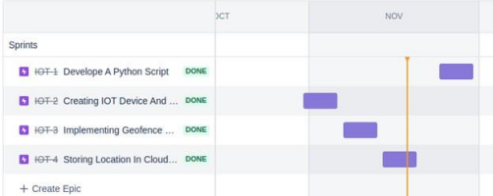

**Chapter 7**

**7.CODING**

**7.1 Coding**

import json

import wiotp.sdk.device

import time

myConfig ={

"identity":{

"orgId": "rdegyk",

"typeId":"safetygad",

"deviceId":"gad1"

},

"auth":{

"token":"gyg06jzil(!lTGsKxV"

}

}

client = wiotp.sdk.device.DeviceClient(config=myConfig, logHandlers=None) client.connect()

while True:

name="locater"

#in area location

#latitude=13.145997614532394

#longitude=80.0619303452179

#out area location

latitude=13.15412

longitude=80.05729

myData={'name':name, 'lat':latitude, 'lon':longitude}

client.publishEvent(eventId="status", msgFormat="json", data=myData, qos=0, onPublish=None)

print("Data published to IBM Iot platform: ",myData)

time.sleep(2)

client.disconnect()

**7.2 Geo-fence**

A geofence is a virtual perimeter for a real-world geographic area.[1] A geofence could be dynamically generated (as in a radius around a point location) or match a predefined set of boundaries (such as school zones or neighborhood boundaries).The use of a geofence is called geofencing, and one example of use involves a location-aware device of a location-based service (LBS) user entering or

exiting a geofence. This activity could trigger an alert to the device's user as well as messaging to the geofence operator. This info, which could contain the location of the device, could be sent to a mobile telephone or an email account.

**Chapter 8**

**8.RESULTS**

**8.1 Performance Metrics**

It is being used as it allows the correct sample of respondents to be selected due to which becomes convenient to obtain results. Besides, the results offered are affordable and usable. Since the respondents are properly chosen, the results tend to be more accurate, precise and reliable.

**Node red connection**:

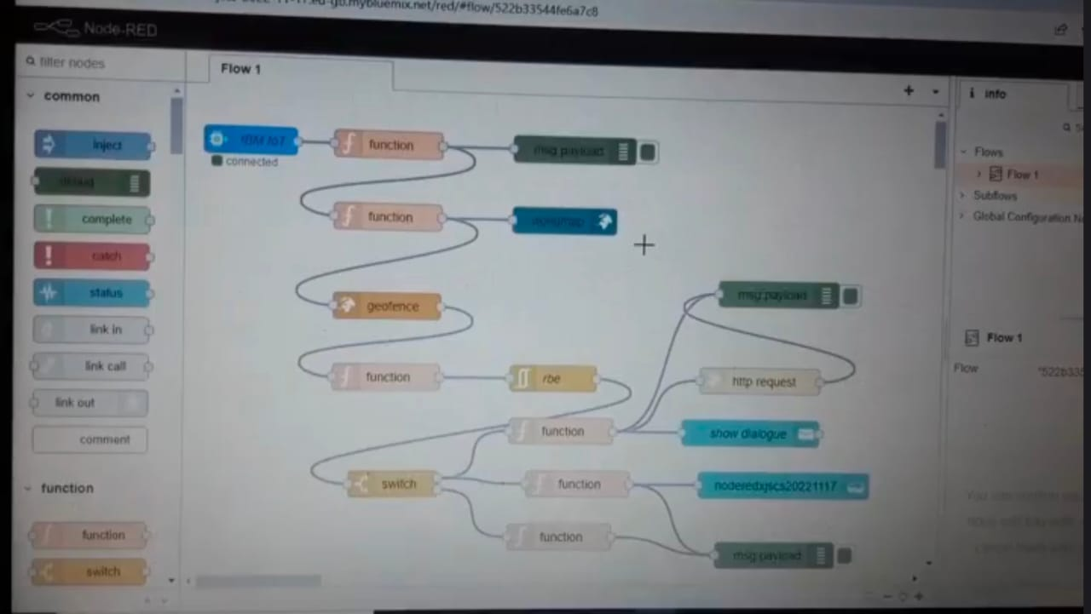

**App front page:**

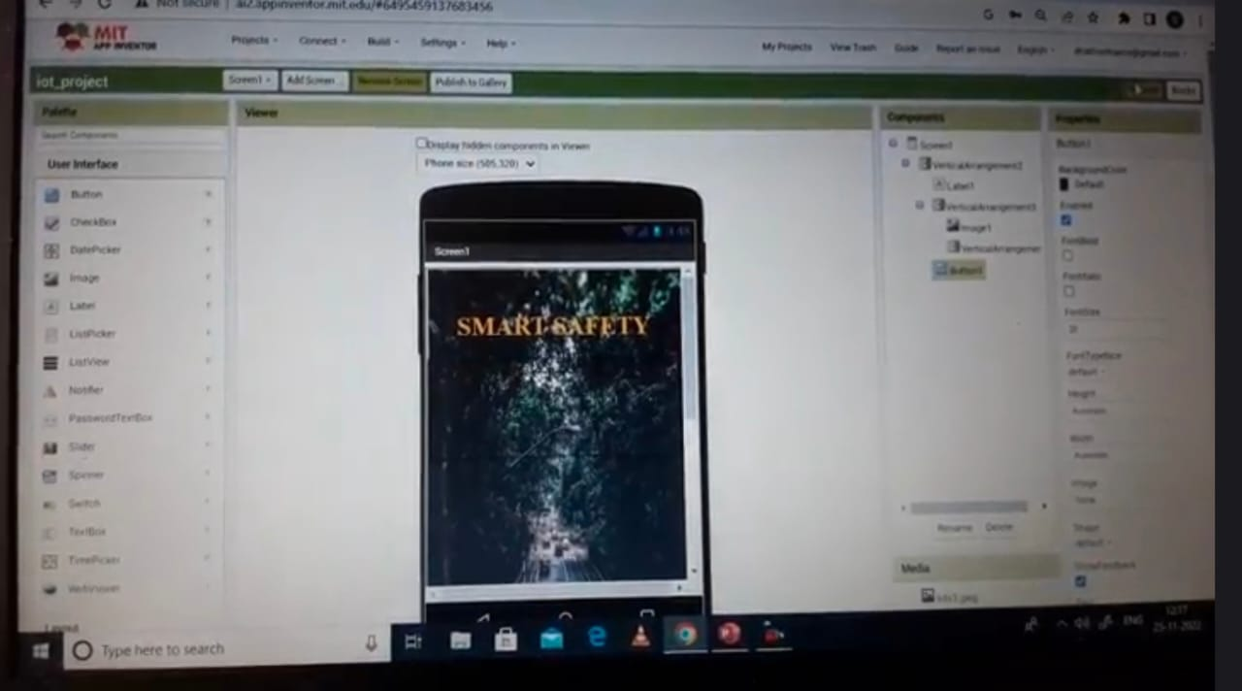

**Sign up page:**

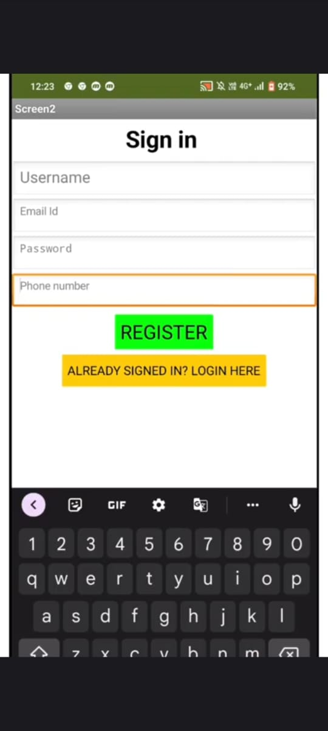

**Location tracking:**

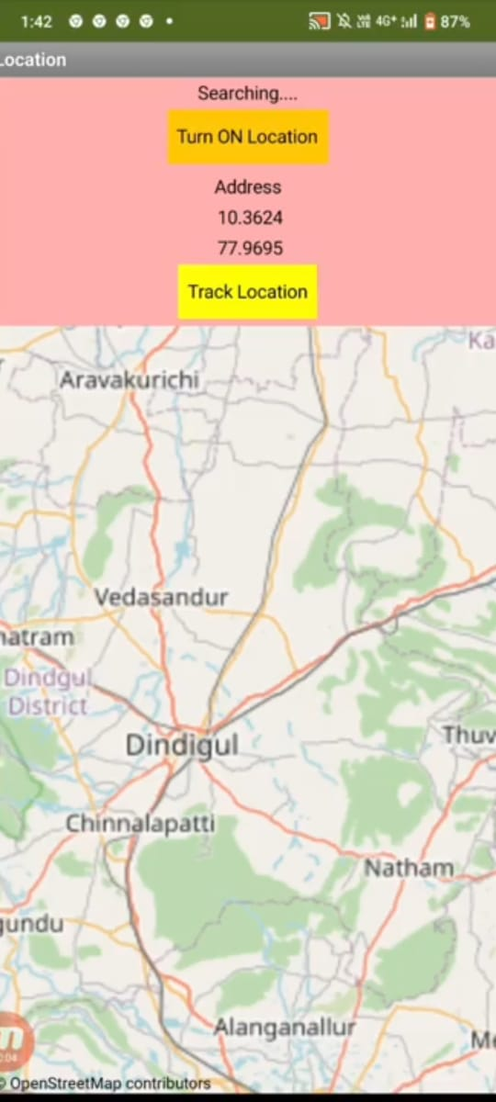

**Chapter 9**

**9.ADVANTAGES & DISADVANTAGES**

**9.1 Advantages**

In our system, we provide an environment where this problem can be resolved in an efficient manner. It makes parents to easily monitor their children in real time just like staying beside them as well as focusing on their own career without any manual intervention.

**9.2 Disadvantages**

It can be easily removed or damaged while playing and by any intruders.This requires internet connectivity to get monitored and to notify alert messages to parents.

**Chapter 10**

**10.CONCLUSION**

The word Future resembles the word Children. As Dr. A.P.J Abdul Kalam’s words “Youngsters are thefuture pillars of one’s nation", today's children are tomorrow's youngsters, preserving their dreams and life for a better future is necessary. Therefore, each and every parent should take care of their own children, without

letting them to fall into the dark world of abusements, which entirely ruin them physically, mentally and emotionally destroying our future. Hence, considering the importance of our future, our project makes it easy for parents to track their children and to visually monitor them on regular basis, which makes them ensure the safety of their children and reduces the rate of incidents of child abuse.

**Chapter 11**

**11.FUTURE SCOPE**

In our system, we automatically monitor the child in real time using Internet of Things, with the help of GPS, GSM, and Raspberry Pi. This system requires network connectivity, satellite communication, and high-speed data connection when we use web camera and GPS to lively monitor. It is difficult to monitor when there occurs any hindrance to satellite communication or any network issue. There also occurs time delay in video streaming through the server. Hence in the future, these issues can be overcome by using Zigbee concept or accessing the system without internet and using high-speed server transmission.

**Chapter 12**

**12.APPENDIX**

**Source Code**

**Code for IN Area Location:**

import json import

wiotp.sdk.device

import time myConfig

={

"identity":{

"orgId": "rdegyk",

"typeId":"safetygad",

"deviceId":"gad1"

},

"auth":{

"token":"gyg06jzil(!lTGsKxV"

} } client =

wiotp.sdk.device.DeviceClient(config=myConfig, logHandlers=None) client.connect() while True: name="locater"

#in area location

latitude=13.145997614532394

longitude=80.0619303452179

myData={'name':name, 'lat':latitude, 'lon':longitude} client.publishEvent(eventId="status", msgFormat="json", data=myData, qos=0, onPublish=None)

print("Data published to IBM Iot platform: ",myData) time.sleep(2)

client.disconnect()

**Code for OUT Area Location:** import json import

wiotp.sdk.device

import time myConfig

={

"identity":{

"orgId": "rdegyk",

"typeId":"safetygad",

"deviceId":"gad1"

},

"auth":{

"token":"gyg06jzil(!lTGsKxV"

} } client =

wiotp.sdk.device.DeviceClient(config=myConfig, logHandlers=None) client.connect() while True: name="locater"

#out area location

latitude=13.15412

longitude=80.05729

myData={'name':name, 'lat':latitude, 'lon':longitude}

client.publishEvent(eventId="status", msgFormat="json",

data=myData, qos=0, onPublish=None)

print("Data published to IBM Iot platform: ",myData)

time.sleep(2)

client.disconnect()

|  |  |
| --- | --- |
| |  | | --- | |  | |

**GitHub Link:** <https://github.com/IBM-EPBL/IBM-Project-43106-1660712964>

**ProjectDemo:** <https://drive.google.com/file/d/1lnwA4jG80bFL668bHm4b31wN_hwa-Ufq/view?usp=drivesdk>